EXPERIMNET 2 .
- AIM:
To design and implement an end-to-end ETL (Extract, Transform, Load) pipeline using Microsoft Power BI's Power Query Editor, enabling the extraction of data from a real-world business dataset, application of transformation logic, and loading of cleansed data into a unified analytical model for reporting and decision-making.

- OBJECTIVES:
- To understand the ETL process and its role in Business Intelligence.
- To extract data from the Global Superstore dataset using Microsoft Power BI.
- To clean, transform, standardize, and integrate data using Power Query Editor.
- To create relationships between multiple tables in the Power BI data model.
- To create analytical measures using DAX.
- To prepare the transformed data for reporting and business analysis.

- TOOLS / SOFTWARE REQUIRED:
- Microsoft Power BI Desktop
- Global Superstore Dataset.xlsx
- Power Query Editor – built into Power BI Desktop
- DAX (Data Analysis Expressions)

- DATASET USED: Global Superstore Dataset.xlsx.

- THEORY:
- ETL (Extract, Transform, Load) is a process used in Business Intelligence to collect data from source systems, transform it into a clean and consistent format, and load it into a centralized environment for analysis.
- Extract: Involves collecting data from the source. In this experiment, data is extracted from the Orders, Returns, and People worksheets of the Global Superstore dataset.
- Transform: Involves cleaning and modifying the extracted data. This includes removing duplicates and blank rows, correcting data types, renaming columns, creating derived columns, standardizing values, and integrating datasets.
- Load: The transformed data is loaded into the Power BI data model, where relationships and analytical measures can be created.
- Power Query Editor acts as the ETL engine in Power BI. Each transformation is recorded as an Applied Step, making the process transparent and reproducible.
- PROCEDURE:
Part A: Extract – Connect to Dataset
Step 1: Download the Global Superstore dataset.
Download the Global Superstore Dataset.xlsx file and save it in the experiment folder.
Step 2: Open Power BI Desktop and connect to the Excel dataset.
Home > Get Data > Excel Workbook
Select Global Superstore Dataset.xlsx > Transform Data
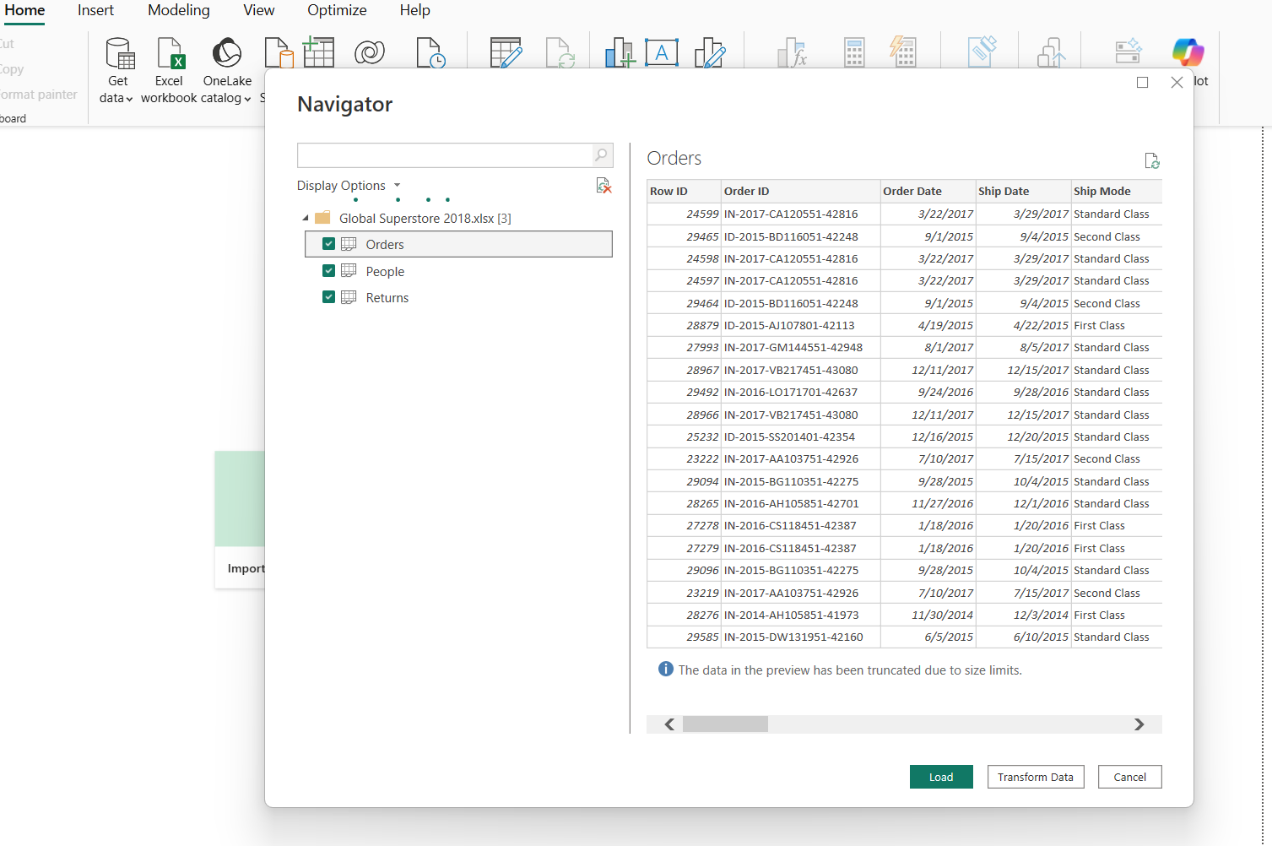
Step 3: Import the required worksheets.
Select the following worksheets:
- Orders
- Returns
- People
Verify that all three tables appear in the Queries pane of Power Query Editor.
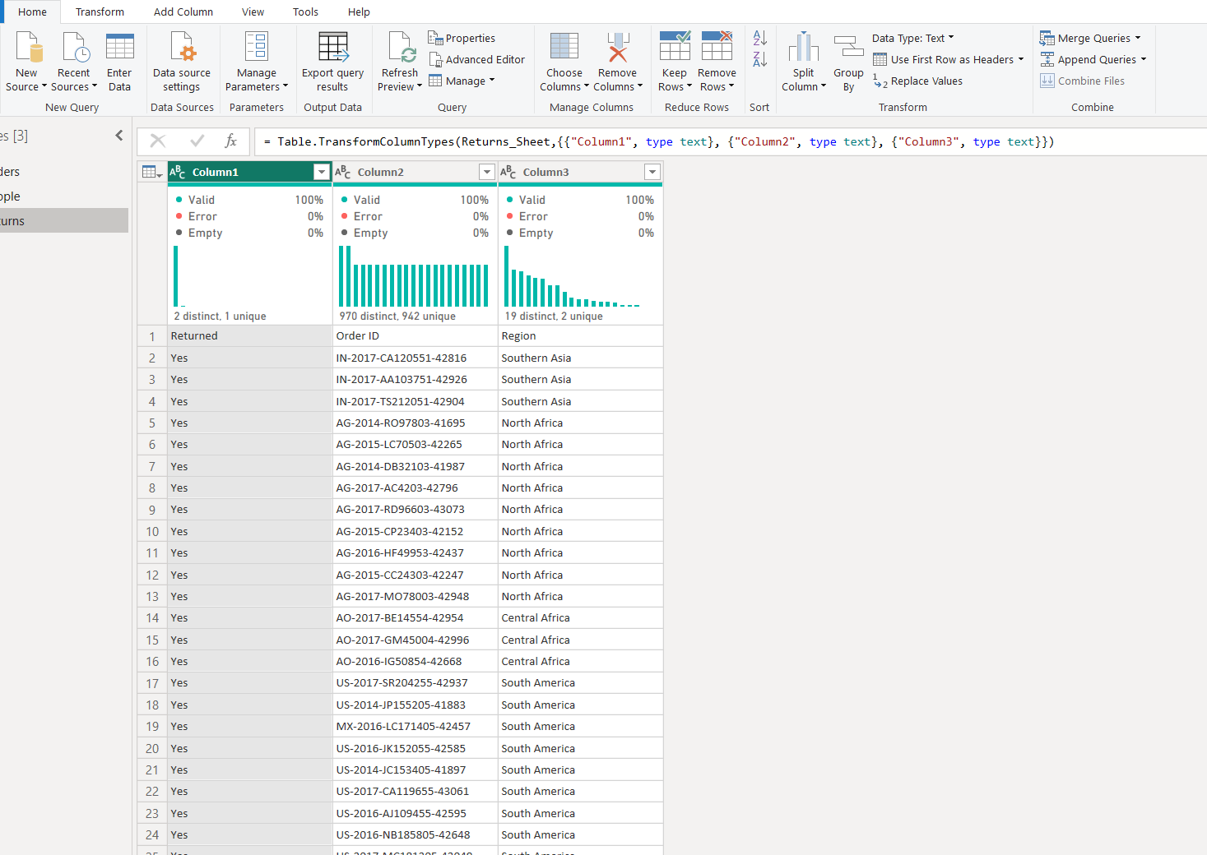
Part B: Transform – Power Query Editor
Step 4: Open Power Query Editor.
Home > Transform Data
Select the Orders table.
Step 5: Transform the Orders table.
Apply the following transformations:
- Remove duplicate records.
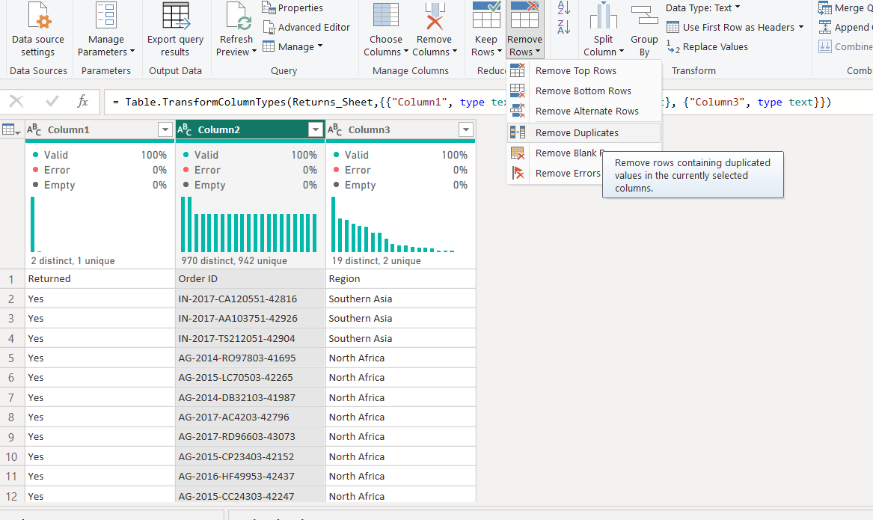
- Remove blank rows.
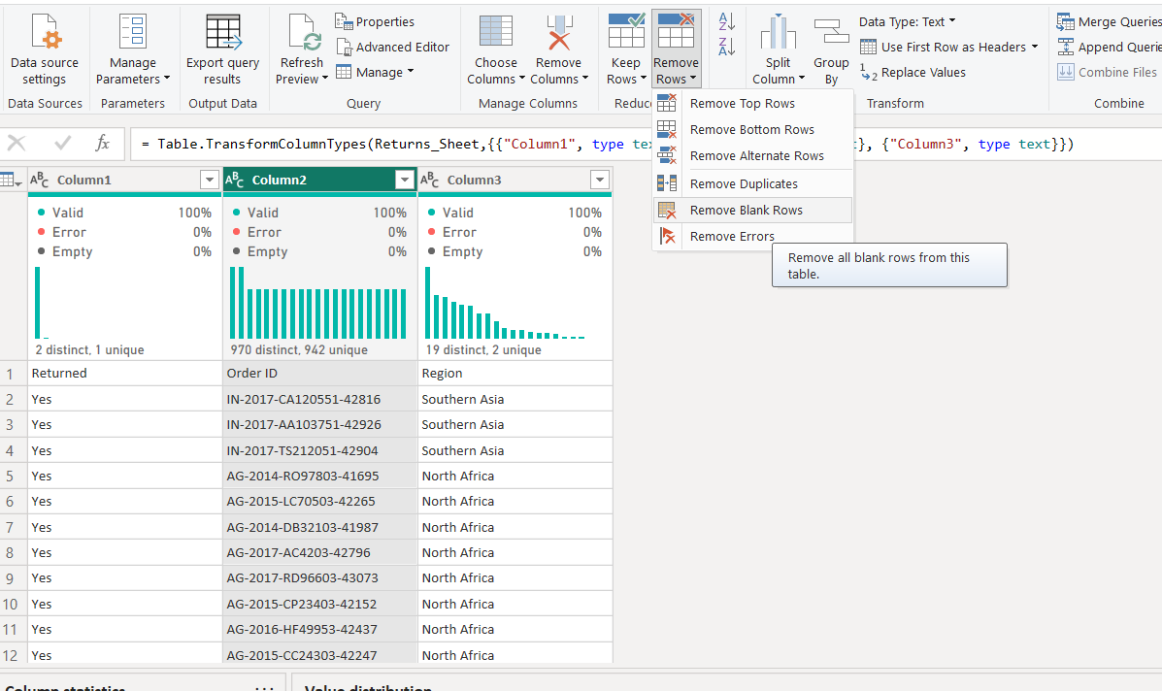
- Verify and correct data types.
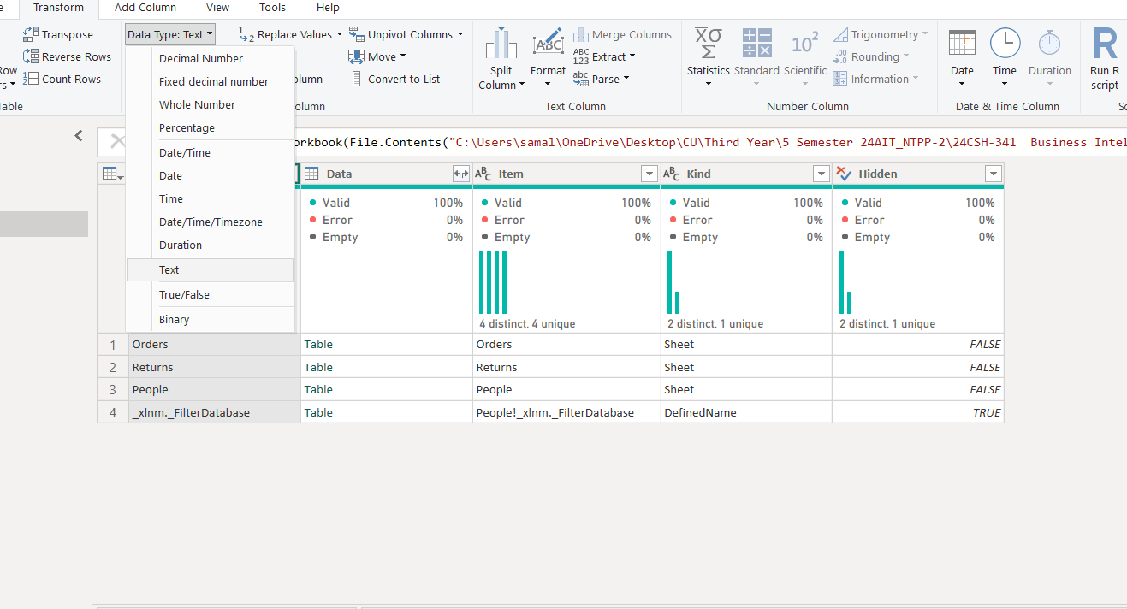
- Rename columns where required.
- Extract Year and Month from Order Date.
- Create a Profit Margin derived column.
- Standardize Region and Segment values.
Review the transformations in the Applied Steps section.
Step 6: Transform the Returns table.
Select the Returns table and:
- Remove duplicate Order IDs.
- Check for missing values.
- Standardize the Returned field values.
Step 7: Transform the People table.
Select the People table and:
- Validate regional assignments.
- Remove unnecessary columns.
- 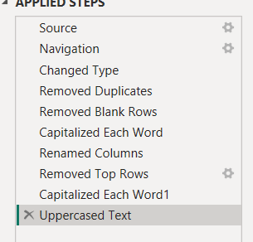
- Verify consistency of region names.
Step 8: Merge the Orders and Returns tables.
Use the Order ID field to merge the two tables.
Orders > Merge Queries > Returns > Order ID
Select the appropriate join condition and apply the merge.
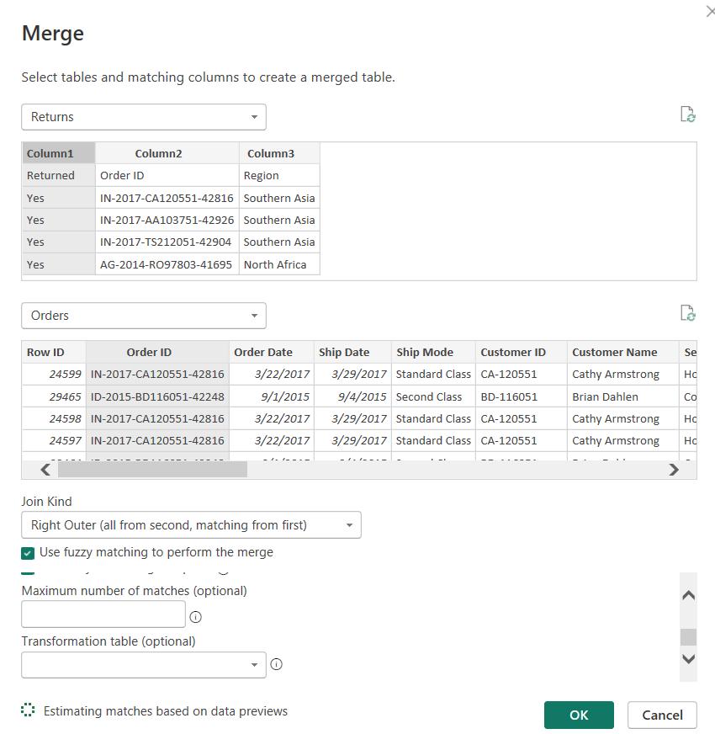
Step 9: Review and apply the transformations.
Review all Applied Steps for the three tables.
Click:
Home > Close & Apply
The transformed data is then loaded into the Power BI data model.
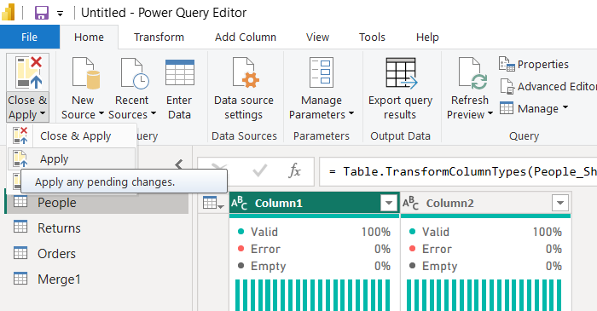
Part C: Load – Build Data Model
Step 10: Open Model View.
Select the Model View icon from the left navigation pane in Power BI.
Step 11: Create relationships between the tables.
Create the following relationships:
  - Orders ↔ Returns using Order ID
  - Orders ↔ People using Region
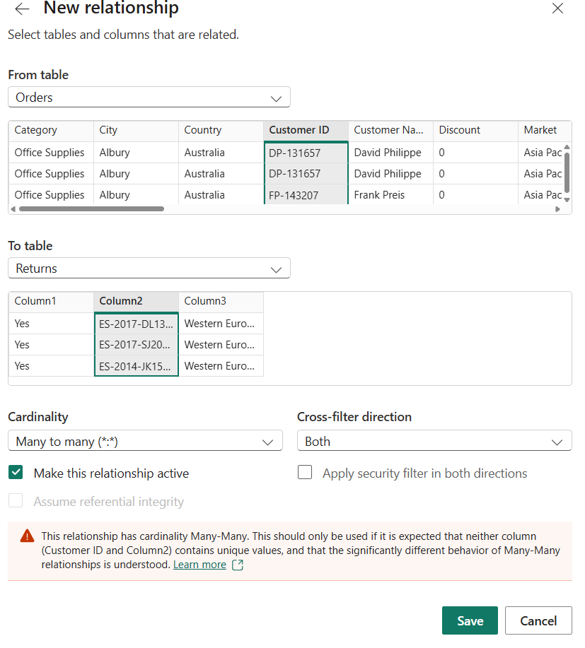
Verify that the relationships are correctly established in the model.
Step 12: Create DAX measures.
Select the Orders table and create the following measures using New Measure:
- Total Sales = SUM(Orders[Sales])
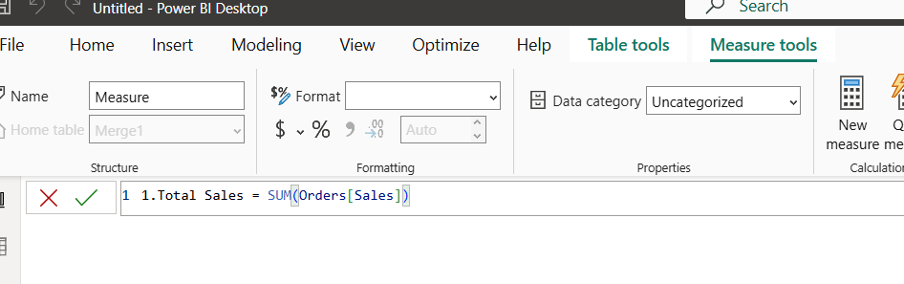
- Total Profit = SUM(Orders[Profit])
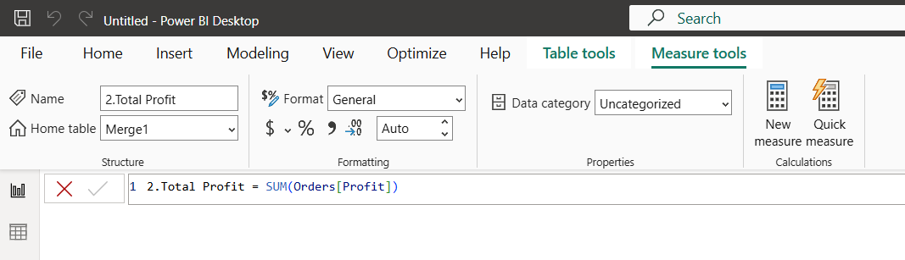
- Profit Margin = DIVIDE(SUM(Orders[Profit]),SUM(Orders[Sales]))
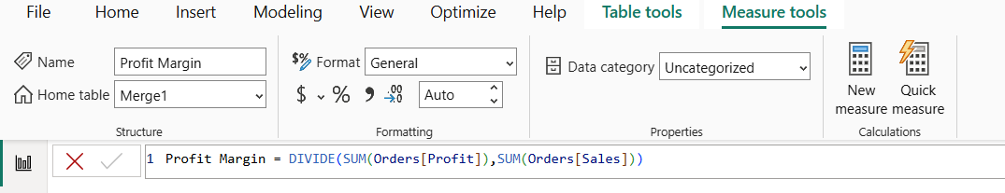
- Total Orders = DISTINCTCOUNT(Orders[Order ID])
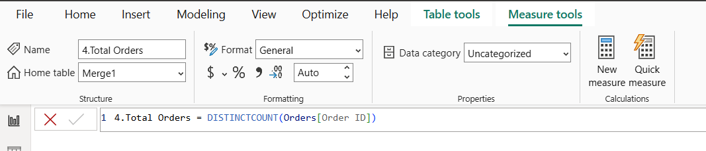
These measures are used to perform analytical calculations and display key business . performance indicators.
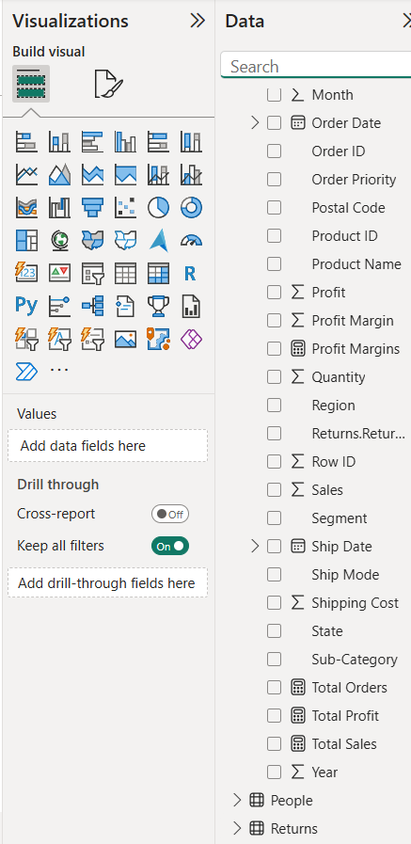
Step 13: Create the BI report/dashboard.
Create a Power BI report using the transformed data and DAX measures.
The final dashboard includes:
- Total Sales
- Total Profit
- Profit Margin
- Total Orders
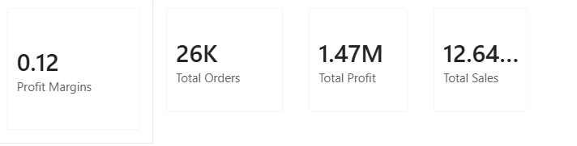
- Sales by Category bar chart
- Profit by Category pie chart
- Profit Margin vs Discount scatter chart
- Detailed Sales & Profit Analysis table
Add the dashboard title:
GLOBAL SUPERSTORE – ETL & SALES ANALYSIS
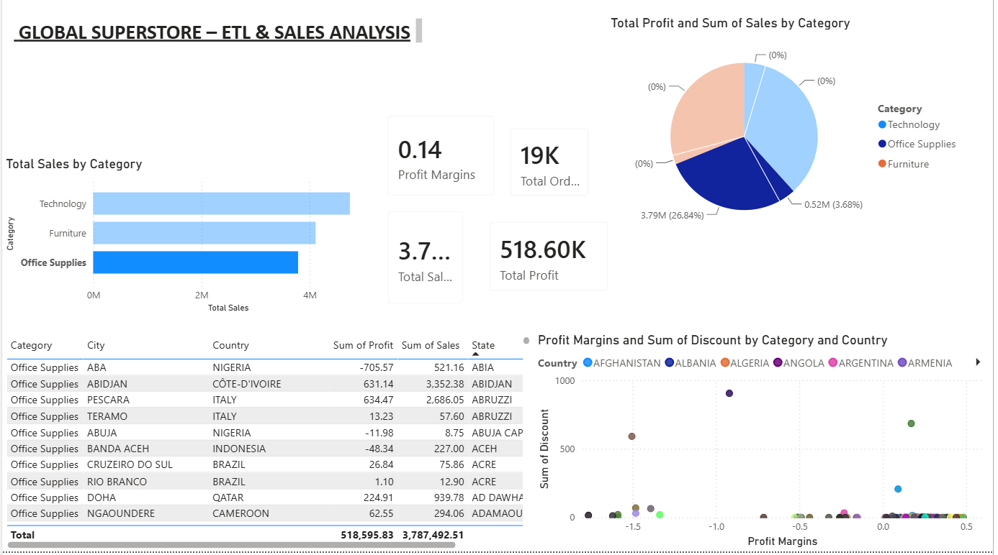

- RESULT
Data was successfully extracted from the Global Superstore dataset, transformed using Power Query Editor, and loaded into the Power BI data model. Data cleaning, standardization, relationship creation, and DAX-based metric generation were performed successfully. The final dataset was prepared for reporting and business analysis.

- LEARNING OUTCOMES
- Understood the ETL process and its role in Business Intelligence.
- Learned how to extract data from a real-world business dataset using Power BI.
- Gained practical experience with Power Query Editor.
- Learned how to clean, filter, transform, and merge datasets.
- Learned how to handle duplicate records, blank values, and data type inconsistencies.
- Learned how to create relationships between multiple tables in Power BI.
- Learned how to create analytical measures using DAX.
- Understood the use of Total Sales, Total Profit, Profit Margin, and Total Orders measures.
- Learned how to create BI visualizations and dashboards for business analysis.
- Gained practical experience in preparing transformed data for reporting and decision-making.

